**//WAP in Drupal to Create Aggregator Module and Book Module.**

**Aggregator Module:**

Step 1- Login in Drupal Administrator (Node)

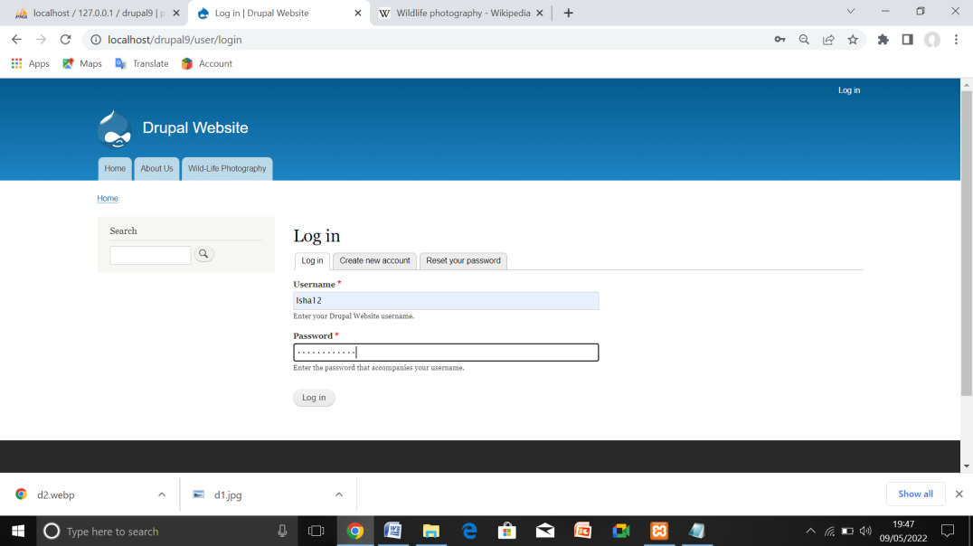

Step 2- Click Modules from the menu bar.

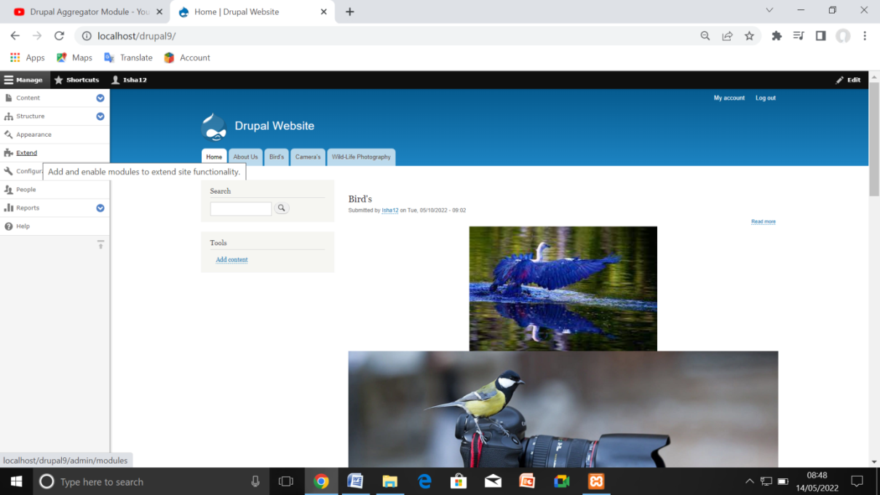

Step 3- A list of different modules gets displayed. Enable the Aggregator module and click Save Configuration as shown in the following screen....

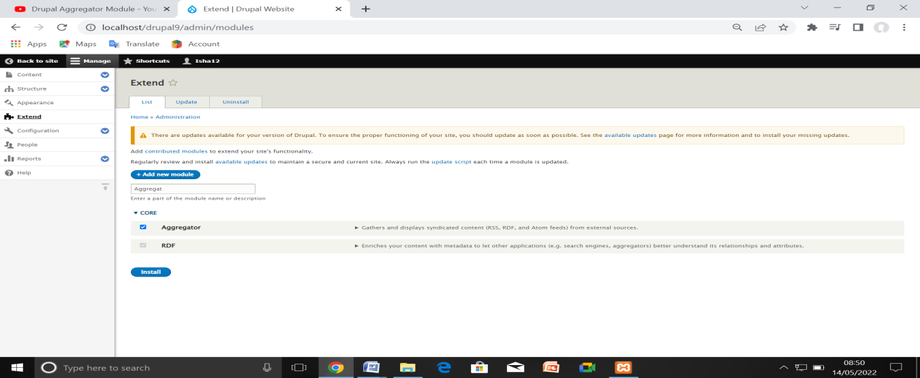

Step 4- Now, go back to the aggregator module and click Configure option on the right side.

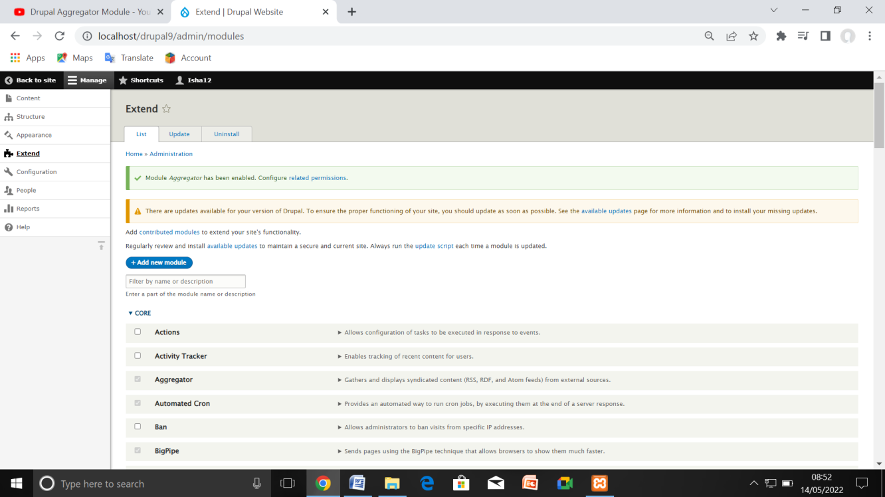

Step 5- Aggregator Module Installed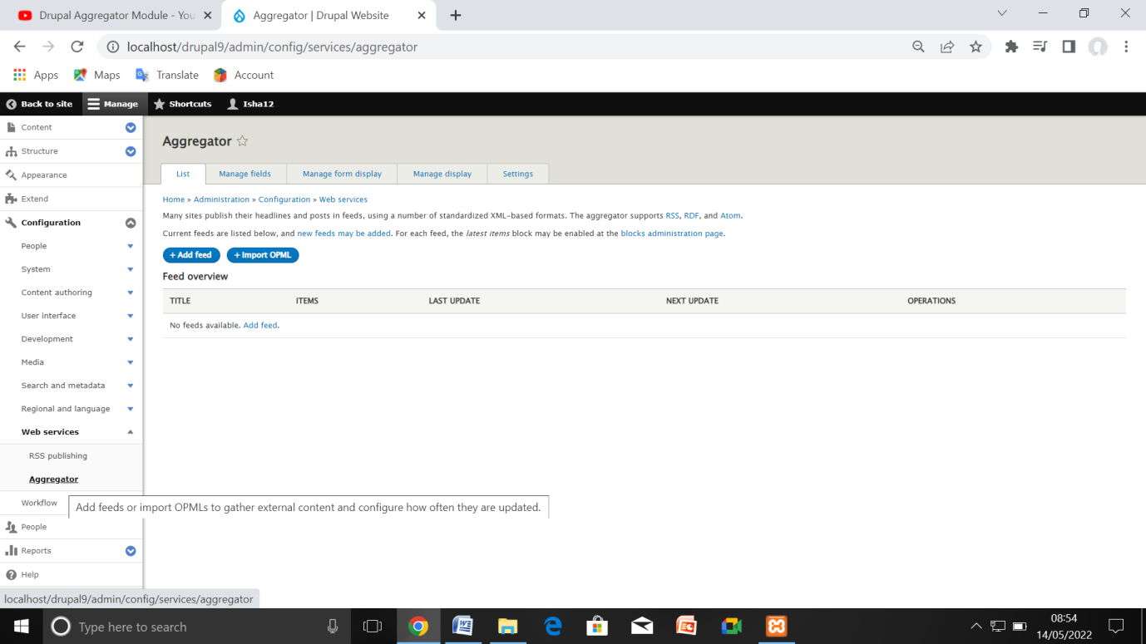

Step 6- Add Feed

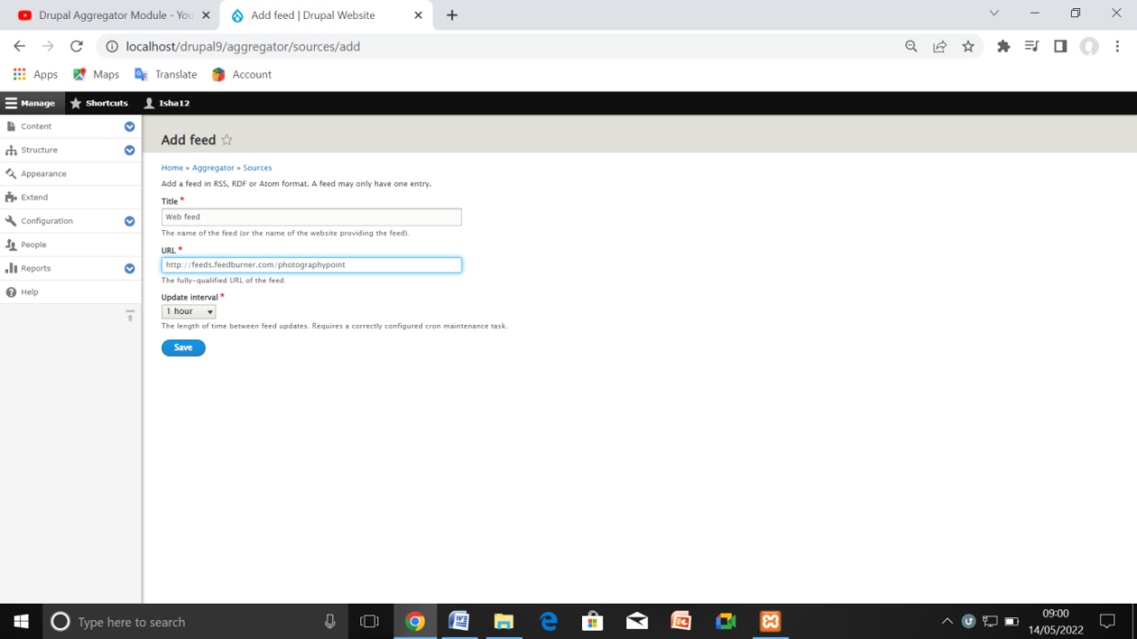

Step 7- Front End (Aggregator Module Created)

